# **HOMEWORK 3 – Partially Observable MDP**

# Exercise 1

1. **Identify the state space, X , the action space A, and the observation space, Z. You should explicitly model the fact that, when the agent does not peek, it sees nothing.**

* State Space: [‘AC’, ‘AD’]

AC: Ace of Clubs

AD: Ace of Diamonds

* Action Space: [‘guessAC’, ‘guessAD’, ‘peek’]
* Observation Space: [‘sawAC’, ‘sawAD’]

1. **Write down the transition probabilities, the observation probabilities and the cost function for this problem. Make sure that the values in your cost function all lie in the interval [0, 1], while respecting the value-relation between actions induced by the rules of the game.**

* Transition Probabilities:
* For action guessAC:



* For action guessAD:

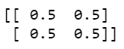

* For action peek:



* Observation Probabilities:
* For action guessAC:



* For action guessAD:



* For action peek:



* Cost Function:



1. **Suppose that, at some time step t, the agent believes that the opponent has the ace of clubs (A♣) with a probability 0.7, decides to peek and observes an ace of diamonds (A♦). Compute the resulting belief.**

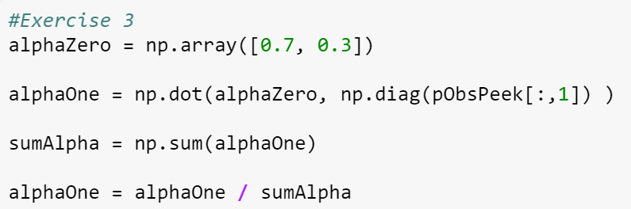

Resulting normalized belief:

